Nguyễn An Phúc – 21IT639

Bài tập về nhà (Thanh ghi)

•Write an API code to execute a program (e.g. notepad.exe) when Windows OS start
–API-> Registry
–HKLM\Software\Microsoft\Windows\CurrentVersion\Run\MyKey
–Name: myProgram
–Run: c:\Windows\notepad.exe
–OpenKey
–RegSetValue
–CloseKey
- Mã code
import winreg

def add_to_startup():
key = r"Software\Microsoft\Windows\CurrentVersion\Run"
value_name = "myProgram"
program_path = r"C:\\Windows\\notepad.exe"

try:
with winreg.OpenKey(winreg.HKEY_LOCAL_MACHINE, key, 0, winreg.KEY_SET_VALUE) as reg_key:
winreg.SetValueEx(reg_key, value_name, 0, winreg.REG_SZ, program_path)
print("Successfully added to startup.")
except PermissionError:
print("Permission denied. Try running the script as Administrator.")
except Exception as e:
print(f"Failed to add to startup: {e}")

if __name__ == "__main__":
add_to_startup()
- Chạy bằng powershell với quyền adminstrator
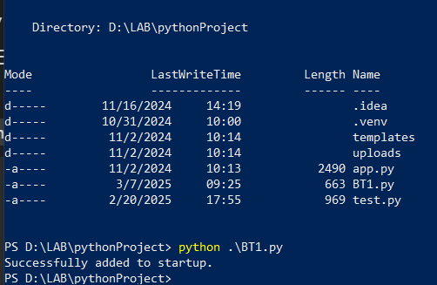
Vào regedit:
Mở đến
HKEY_LOCAL_MACHINE\Software\Microsoft\Windows\CurrentVersion\Run
Thấy khóa myProgram trỏ đến C:\Windows\notepad.exe
